SIMATS ENGINEERING (SAVEETHA SCHOOL OF ENGINEERING)
Department of Computer Science and Engineering
CO2 ASSESSMENT TOOL 2 – Architecture Design Assignment

Course Code: | CSA10 / CSA1005 | Course Title: | Software Engineering
CO Assessed: | CO2 | Assessment: | Assessment Tool 2 – Architecture Design Assignment
Weightage: | 20% | Total Marks: | 25
CO2 Statement: | Perform detailed requirements analysis, design scalable architectures, and prioritize features with a focus on cross-disciplinary skills
Student Name: | S . Adhi kesavan | Reg. No.: | 192521172
Date: |  | Duration: | 60 minutes

Code of Conduct
I S.Adhikesavan - 192521172 (Name / Reg No) certify that this submission is my original work and that I have adhered to the guidelines specified for this assessment. I understand that any violation of academic integrity rules will result in disciplinary action.
Signature of the Student: _________________________
Annexure A – Architecture Design Assignment
Instructions to Students:
Each student will be assigned an individual software project problem statement. Based on the assigned problem, analyze the system requirements and design an appropriate software architecture by applying software engineering principles. Your submission should demonstrate your ability to select, justify, and evaluate a suitable architectural style.

Question :
Based on your assigned problem statement, perform an Architecture Design Analysis and prepare an architecture design report by answering the following questions:

1. Analyze System Requirements
- Study the given problem statement and identify the system objectives.
- Analyze the functional and non-functional requirements that influence the software architecture.
- Identify key quality attributes such as scalability, maintainability, reliability, availability, performance, and security.

2. Select a Suitable Software Architecture
- Select an appropriate architectural style for the proposed system (e.g., Layered Architecture, Client-Server, MVC, Microservices, Event-Driven, Service-Oriented Architecture, Serverless, or Hybrid Architecture).
- Justify why the selected architecture is the most suitable for the given problem.

3. Draw the Software Architecture Diagram
- Design a clear architecture diagram illustrating the overall structure of the proposed system.
- Include all major layers/components, databases, external systems, APIs, and communication mechanisms.
- Use appropriate software architecture notations and labels.

4. Explain Components and Their Interactions
- Describe the purpose and responsibilities of each architectural component.
- Explain how the components communicate and exchange data.
- Illustrate the overall workflow of the system.

5. Discuss Quality Attributes
Evaluate how the proposed architecture addresses the following aspects:
- Scalability
- Security
- Performance
- Reliability
- Maintainability
- Availability

6. Justify Architectural Decisions
- Explain the rationale behind your architectural choices.
- Discuss the trade-offs considered while selecting the architecture.
- Explain how the chosen architecture supports future enhancements, system integration, and long-term maintainability.

SOLUTION :

INTRODUCTION :

The AI-Powered Medical Appointment Follow-Up and Care Coordination System is designed to improve the management of patient appointments, diagnostic tests, medication reviews, and follow-up consultations. In traditional healthcare systems, manual tracking of appointments and pending medical tasks can lead to missed consultations, delayed diagnostic results, and communication gaps between patients and healthcare professionals.
The proposed system provides a centralized platform for managing patient follow-ups, monitoring diagnostic test statuses, assigning tasks to healthcare staff, and sending automated reminders. It also includes an AI support module to help identify overdue follow-ups and prioritize cases using configured rules or validated predictive models.
The system aims to improve coordination between patients, doctors, nurses, laboratory staff, and administrators while maintaining the privacy and security of medical information.

ANALYZE SYSTEM REQUIREMENTS

System Objectives

The main objectives of the proposed system are:

- To maintain patient records and follow-up schedules.
- To manage upcoming and pending medical appointments.
- To track diagnostic tests and their result statuses.
- To send automatic reminders to patients and authorized healthcare staff.
- To improve communication and coordination among healthcare professionals.
- To provide dashboards and reports for monitoring pending tasks.
- To use AI-assisted features to identify overdue follow-ups and support task prioritization.

FUNCTIONAL REQUIREMENTS
Functional requirements describe the operations that the system must perform
FR1: Patient Management
The system shall allow authorized staff to register patients and maintain their relevant information.
FR2: Appointment Scheduling
The system shall allow authorized users to create, update, cancel, and manage appointments and follow-up schedules.
FR3: Diagnostic Test Tracking
The system shall track diagnostic test requests and display their statuses, such as pending, in progress, and completed.
FR4: Notification Management
The system shall send reminders for upcoming appointments, pending diagnostic tests, and overdue follow-up activities.
FR5: Task Assignment
The system shall allow authorized staff to assign follow-up tasks to appropriate healthcare team members.
FR6: Dashboard Management
The system shall provide dashboards showing upcoming appointments, pending tasks, and diagnostic status information.
FR7: AI-Assisted Follow-Up
The system shall support the identification of overdue follow-ups and help prioritize cases according to configured rules or validated AI models.
FR8: Report Generation
The system shall generate reports about completed appointments, pending tests, overdue follow-ups, and task completion.
FR9: Access Control
The system shall restrict access to patient information according to the user's role and permissions.

NON-FUNCTIONAL REQUIREMENTS
Non-functional requirements describe the quality and performance expected from the system.
• Scalability: The system should support an increasing number of patients, appointments, and healthcare staff.
• Security: Patient information must be protected using authentication, authorization, and encryption.
• Performance: The system should retrieve appointment details and update task statuses efficiently.
• Reliability: The system should preserve accurate patient and appointment information and recover from failures.
• Availability: The system should remain accessible to authorized users with minimal downtime.
• Maintainability: The software should allow individual modules to be modified and tested easily.
• Usability: The interface should be simple and understandable for patients and healthcare professionals.
• Privacy: Access to confidential medical information must be limited to authorized users.

SELECT A SUITABLE SOFTWARE ARCHITECTURE
Selected Architecture: Layered Architecture with MVC
The proposed system uses a Layered Architecture combined with the Model–View–Controller (MVC) design pattern.
Layered Architecture separates the application into logical layers, with each layer responsible for specific operations. MVC organizes the application interface and its interaction with application data and control logic.
This combination is suitable for the proposed healthcare system because it separates the user interface, business operations, database access, and data storage.
ARCHITECTURE LAYERS
Presentation Layer
This layer provides the user interface for patients, doctors, nurses, laboratory staff, and administrators. It displays appointment information, notifications, patient details, and dashboard reports.
Application and Business Logic Layer
This layer processes the main operations of the system. It contains patient management, appointment scheduling, follow-up management, diagnostic tracking, task coordination, notification management, and AI-assisted support.
Data Access Layer
This layer manages communication between the application and the database. It performs database queries, validates data access operations, and retrieves or updates stored information.
Database Layer
This layer stores patient profiles, appointment schedules, diagnostic test statuses, follow-up records, user permissions, and task information.
External Integration Layer
This component connects the application to external notification services, such as email or SMS providers, and authorized hospital or laboratory systems through APIs.
JUSTIFICATION FOR SELECTING THE ARCHITECTURE
Layered Architecture with MVC is suitable because the healthcare system contains multiple related functions that must be organized clearly. Separating these functions improves code readability, testing, maintenance, and security management.
For example, changes to the patient dashboard can be made mainly within the presentation layer without requiring major changes to database operations. Similarly, notification services can be integrated through defined interfaces.
The architecture is also appropriate for a student-level project because it is easier to design and implement than a complex microservices architecture.
SOFTWARE ARCHITECTURE DIAGRAM
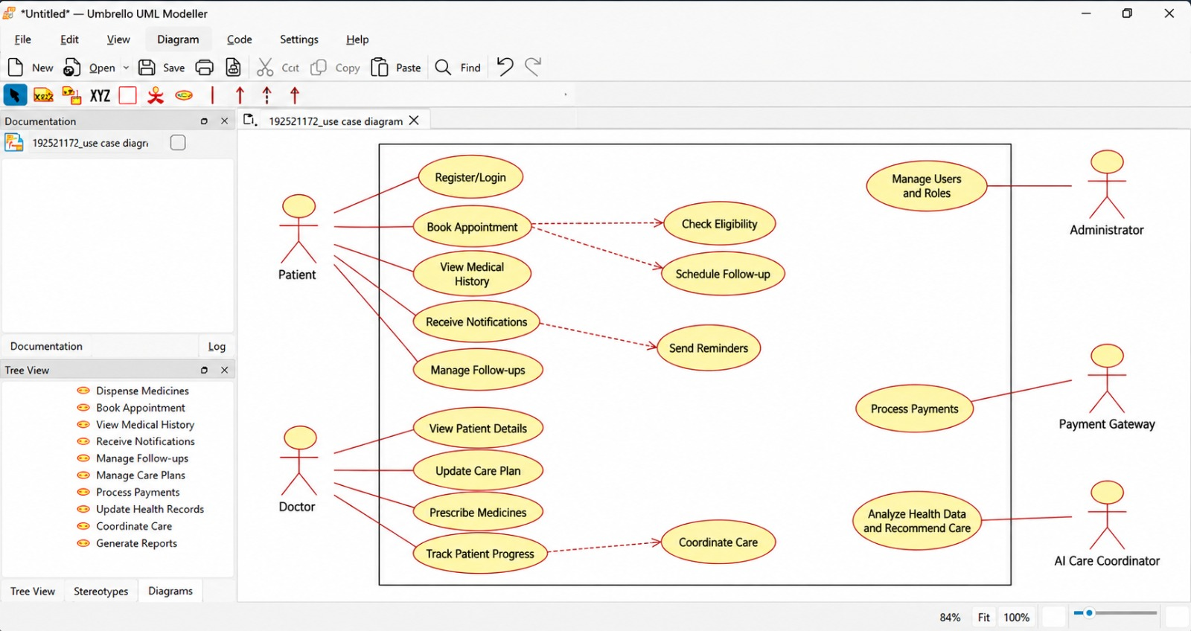

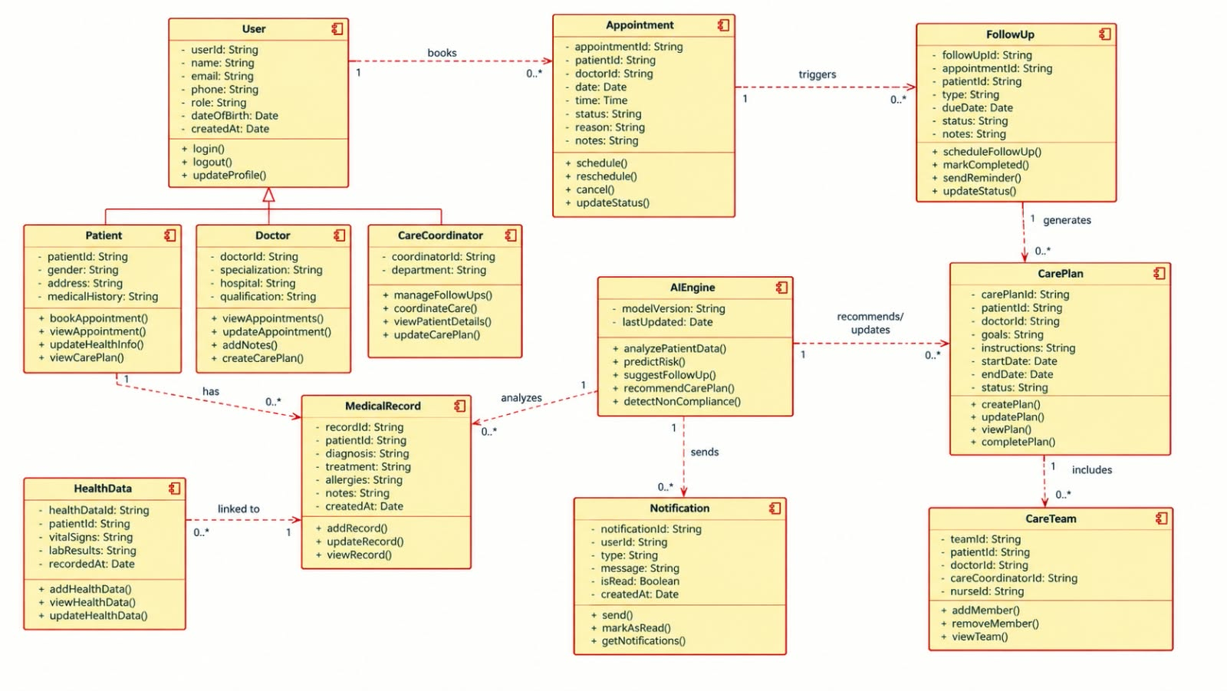
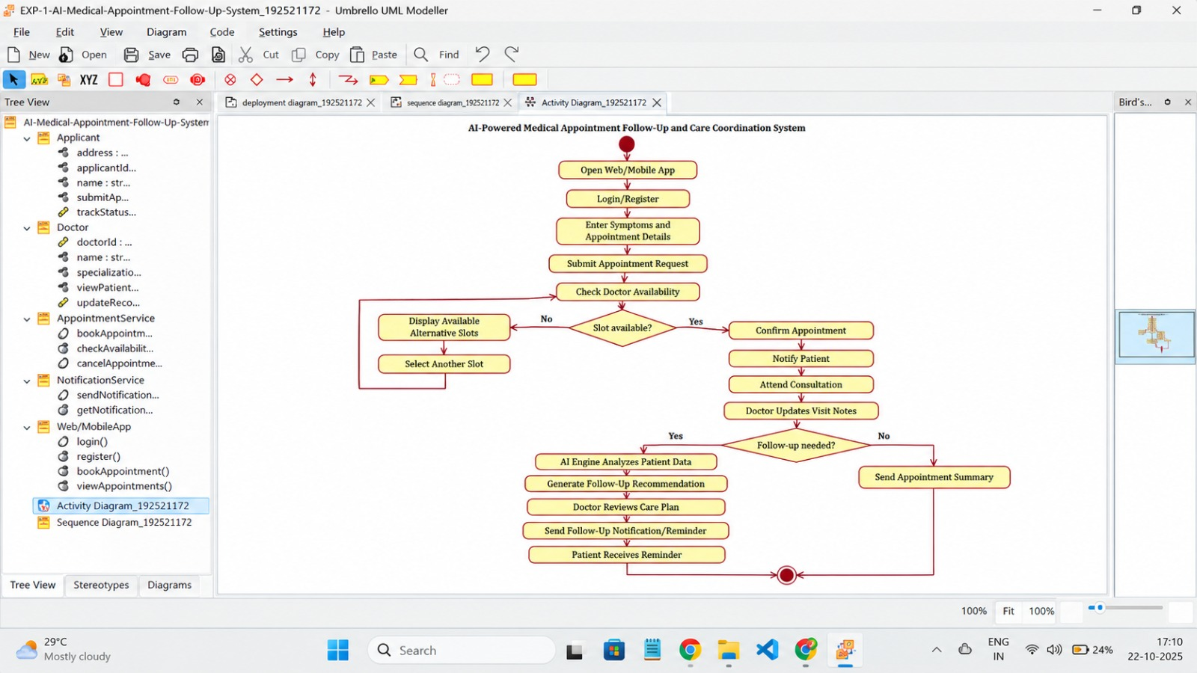
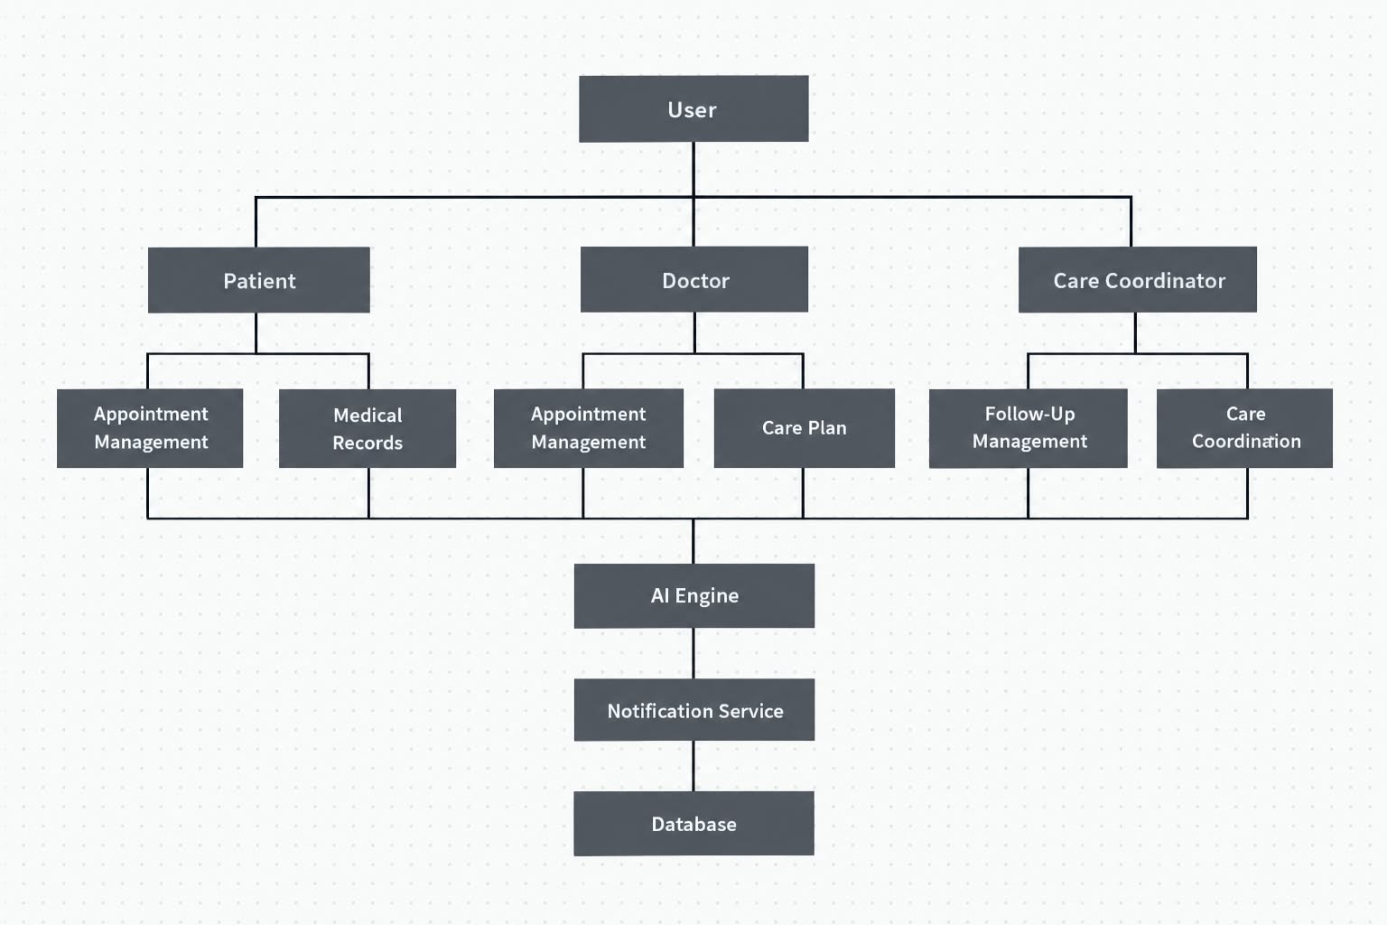
The following diagram represents the overall architecture of the proposed system.
Diagram explanation: Users interact with the presentation layer. Their requests are processed by the application layer, which applies business rules and communicates with the database through the data access layer. The application can also communicate with external notification providers and authorized hospital or laboratory systems through APIs.
The AI-assisted support module uses relevant, authorized data to identify overdue follow-ups and assist with prioritization. Any clinical decision-making must remain subject to appropriate clinical oversight.
EXPLAIN COMPONENTS AND THEIR INTERACTIONS
User Interface Component
The user interface provides access to the system for patients and healthcare staff. Patients can view their appointments and reminders, while healthcare staff can monitor pending consultations, diagnostic tests, and follow-up activities.
Patient Management Component
This component maintains patient profiles and relevant registration details. It allows authorized staff to create and update patient records while enforcing access permissions.
Appointment Scheduling Component
This component manages appointment creation, modification, cancellation, and follow-up scheduling. It helps healthcare staff identify upcoming consultations and appointments that require attention.
Diagnostic Tracking Component
This component maintains diagnostic test requests and tracks their progress. It allows authorized staff to identify pending tests and determine whether results have been received.
Follow-Up Management Component
This component manages follow-up schedules, medication review reminders, and periodic monitoring activities. It helps prevent follow-up tasks from being overlooked.
Notification Component
This component generates reminders for upcoming appointments, pending diagnostic activities, and overdue follow-ups. It communicates with external email or SMS services through APIs.
AI-Assisted Support Component
This component can analyze authorized scheduling and task-status data to identify overdue follow-ups and help prioritize cases. Its recommendations should be explainable, validated, and reviewed by authorized healthcare professionals when they may affect patient care.
Data Access Component
This component provides controlled access to stored data. It executes database operations and helps maintain consistency between application functions and stored records.
Database Component
The database stores patient information, appointment schedules, diagnostic statuses, follow-up tasks, user roles, and notification records. Appropriate access controls, backups, and data-integrity rules protect the stored information.
Overall System Workflow
The system follows these steps:
- An authorized user logs into the system.
- The application verifies the user's identity and permissions.
- The user registers a patient or schedules an appointment.
- The application processes the request and stores the information in the database.
- The follow-up module monitors scheduled activities and pending tasks.
- The notification component sends reminders through an external service when required.
- Healthcare staff update appointment and diagnostic statuses through the dashboard.
- The AI-assisted module can identify overdue tasks and provide prioritization support.
- The system generates reports to help staff monitor follow-up activities.
DISCUSS QUALITY ATTRIBUTES
Scalability
Layered Architecture supports scalability by separating major responsibilities. The application can be deployed on suitable infrastructure and its resources can be increased as the number of patients and users grows. Database indexing and optimized queries can also improve performance as records increase.
Security
Security is essential because the system stores confidential patient information. Authentication verifies user identity, while role-based access control restricts users to the information required for their responsibilities. Encryption, secure API communication, audit logs, and input validation help protect sensitive data.
Performance
The system can improve performance through efficient database queries, appropriate indexing, caching of suitable non-sensitive information, and optimized application logic. Notification processing can be performed asynchronously so that sending an email or SMS does not unnecessarily delay the user's request.
Reliability
Reliability can be improved through database transactions, regular backups, error handling, data validation, and recovery procedures. The system should also record notification failures and provide a mechanism for retrying unsuccessful deliveries.
Maintainability
The architecture separates the interface, business logic, data access, and storage responsibilities. Developers can update the notification component or appointment management functions with fewer changes to unrelated parts of the application. Modular code and automated testing further improve maintainability.
Availability
Availability can be improved through infrastructure monitoring, database backups, recovery procedures, and redundant deployment where necessary. Health checks and failure alerts help administrators identify problems quickly. High availability requires appropriate infrastructure in addition to a suitable architecture.
Summary of Quality Attributes
Quality Attribute | Architectural Support
Scalability | Separate layers and scalable infrastructure
Security | Authentication, authorization, encryption, and audit logs
Performance | Efficient queries, indexing, caching, and asynchronous notifications
Reliability | Transactions, backups, validation, and recovery procedures
Maintainability | Modular components and separation of concerns
Availability | Monitoring, redundancy, and recovery mechanisms

JUSTIFY ARCHITECTURAL DECISIONS
RATIONALE BEHIND THE ARCHITECTURE
Layered Architecture with MVC was selected because it provides a clear separation of responsibilities and supports the main requirements of the healthcare follow-up system.
The presentation layer handles user interactions, the application layer processes healthcare workflow operations, the data access layer manages database communication, and the database layer stores information.
MVC further organizes the interface-related logic and helps separate display responsibilities from application control and data handling.
ADVANTAGES
- Clear separation of concerns: Each layer has a defined responsibility.
- Easy maintenance: Individual components can be modified with limited impact on other components.
- Improved testing: Business operations and data access can be tested separately.
- Security management: Access controls can be enforced at appropriate application and data boundaries.
- Integration support: External notification and laboratory services can be connected through APIs.
- Future enhancements: Additional modules can be introduced as the project grows.

TRADE-OFFS
Although the architecture has several benefits, some limitations must be considered.
- Requests may pass through multiple layers, introducing additional processing overhead.
- Poorly designed layers can create unnecessary dependencies.
- Scaling the complete application may be less resource-efficient than scaling individual microservices.
- Integrating external services introduces dependency and communication-failure risks.
- Security controls, testing, monitoring, and backup procedures require additional implementation effort.

CONCLUSION
The AI-Powered Medical Appointment Follow-Up and Care Coordination System is designed to improve the management of appointments, diagnostic tests, follow-up schedules, and healthcare staff coordination.
Layered Architecture combined with MVC provides a suitable foundation because it separates user interactions, application logic, data access, and storage. This separation supports maintainability, testing, security management, and integration with external services.
The proposed architecture addresses important quality attributes, including scalability, security, performance, reliability, maintainability, and availability, when supported by appropriate implementation practices and infrastructure.

RUBRICS FOR CALCULATION

Evaluation Criteria | Excellent (4 Marks) | Good (3 Marks) | Satisfactory (2 Marks) | Needs Improvement (1 Mark)
System Requirement Analysis (30%) | Thoroughly analyzes the problem statement, accurately identifies functional and non-functional requirements, and clearly explains quality attributes influencing the architecture. | Analyzes most requirements with minor omissions or limited explanation. | Identifies only basic requirements with partial analysis. | Requirement analysis is incomplete, inaccurate, or lacks clarity.
Selection of Software Architecture (25%) | Selects the most appropriate architectural style with strong technical justification aligned to system requirements. | Selects a suitable architecture with reasonable justification. | Architecture is partially suitable with limited justification. | Inappropriate architecture selected or justification is missing.
Architecture Diagram and Component Design (20%) | Produces a clear, complete, and well-structured architecture diagram with all major components, interfaces, and interactions accurately represented. | Diagram is mostly complete with minor omissions or notation issues. | Diagram includes only essential components and lacks sufficient detail. | Diagram is incomplete, unclear, or technically incorrect.
Component Interaction and Quality Attribute Analysis (15%) | Clearly explains component responsibilities, interactions, and thoroughly discusses scalability, security, performance, reliability, maintainability, and availability. | Explains most components and quality attributes with minor gaps. | Provides limited explanation of interactions and addresses only some quality attributes. | Component interactions and quality attributes are poorly explained or missing.
Architectural Justification and Technical Presentation (10%) | Provides strong justification for architectural decisions, discusses trade-offs and future enhancements, and presents a well-organized, professional report. | Provides adequate justification with minor gaps; report is well organized. | Limited justification with minimal discussion of trade-offs or future scope; report needs improvement. | Justification is weak or absent; report lacks organization and technical clarity.

Criteria | Mark
System Requirement Analysis (30%) | /5
Selection of Software Architecture (25%) | /5
Architecture Diagram and Component Design (20%) | /5
Component Interaction and Quality Attribute Analysis (15%) | /5
Architectural Justification and Technical Presentation (10%) | /5
TOTAL | /25

